P R E S S R E L E A S E

Local Writer Releases New Book Nationally

John Lent is releasing a new book of poems this fall in Canada. The book is called A Matins Flywheel, it’s set in Vernon, and it has been published by Thistledown Press in Saskatoon. This is Lent’s eleventh book over a long, forty-five year career of publishing poetry, fiction and non-fiction. The book launch will be at 7:00pm at The Okanagan Regional Library, Vernon Branch. Everyone is welcome. The reading is free. There will be books for sale. The doors will open at 6:30pm. Accompanying Lent will be Kerry Gilbert, another Vernon poet, reading from her new book, Little Red, published by MotherTongue Press last spring.
Both writers are part of an energetic and explosive community of writers who live and write in the Okanagan. “In some ways,” Lent said, “The Okanagan Valley has one of the most vibrant and exciting professional writers’ communities in the country. It includes an amazing list of mostly young men and women who have published nationally and internationally and who have made their homes here. Kerry Gilbert is one of those dazzling young writers, and it will be so much fun to read with her.” Of his own new book, Lent says, “I suspect the vision of A Matins Flywheel---the density of it---is something I’ve been reaching for over a long period of time now. I wanted to write a series of meditations or investigations on the texture of day to day life, and I wanted them to carry a solid weight of considerations that could be played by a pianist as whimsical and spacious as Bill Evans or a bass player as subtle as Charlie Haden.”
“I am also, of course, getting older,” Lent continued, “and have entered that zone of life where health issues surface and demand attention we didn’t need to expend when we were younger. Part of the weight in this book addresses some of those concerns and how my wife, Jude, and I have managed to get through and past a variety of pressures and crises from that point of view, and are still standing here, joyous and healthy.”
This fall, Lent will launch A Matins Flywheel with a series of readings in Kelowna, Nelson, Nanaimo, Duncan, Vancouver, Edmonton and Saskatoon.
John Lent taught writing and literature at Okanagan College for over thirty years and sings in the successful roots/blues/jazz trio, The Lent/Fraser/Wall Trio. He lives here in Vernon with his wife, the visual artist, Jude Clarke.

John Lent and Kerry Gilbert
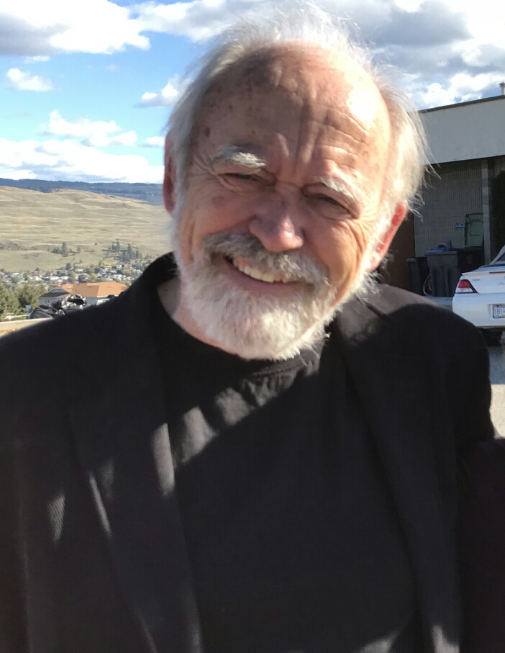

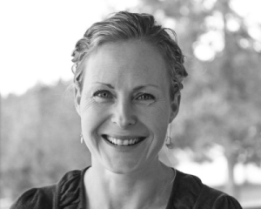

If you need more information on either John Lent or Kerry Gilbert, please go to their websites:
johnlent.ca
kerrygilbert.ca

